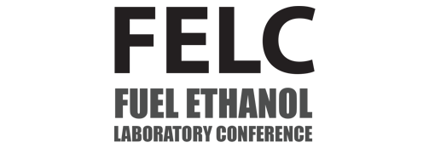
Omaha Marriott Downtown at the Capitol District
222 N 10th St, Omaha, NE 68102

Speaker Submission
- Please complete the form below to be included in the print program and FELC website.
- Submit this form to marketing@midlandsci.com
Full Name:
Job Title:
Company:
Email:
Bio (under 500 characters):

Presentation Title:
Presentation Summary (under 750 characters):

*Additional Materials*
1. Please submit a headshot photo

